**DIOCESE OF BRADFORD**

#### Heaton St. Barnabas’ Church of England (VA) Primary School

**Rossefield Road, Heaton, Bradford, BD9 4DA**

**Tel: 01274 545019 / Fax: 01274 487767**

Headteacher: Mrs D. Smith NPQH

[www.hstb.co.uk](http://www.hstb.co.uk)

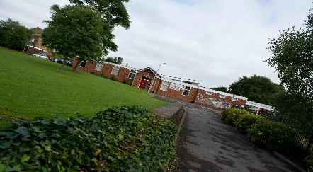*‘Unity in Diversity’*

**SITE MANAGER**

NJC 18 to 21 Dependent on Experience

Perm/Full Time 37hpw/All Year Round)

Required for September 2015

Heaton St Barnabas is a two form entry primary school, situated in beautiful surroundings on the fringe of the city of Bradford. Our children are from a wide range of cultural and ethnic backgrounds and each child is very special to us. **Our most recent Ofsted in July 2014 was GOOD**

**The children, staff and governors are looking to appoint a highly motivated and experienced Site Manager to be responsible for cleaning, security, heating, general maintenance, minor repairs and other associated tasks, as and when required. The successful applicant will be required to live on site, in the modern, detached School house.**



**We are looking for someone who:**

* Values every child and the religious/cultural diversity of our school.
* Has a flexible approach to work.
* Is willing to undertake necessary training. (including First Aid)
* Is able to lead and direct a team of premises staff.
* Is well motivated, friendly & sympathetic to staff, parents and children.
* Has relevant experience of caretaking, cleaning and or small repairs work.



**We can offer you:**

* A modern detached 3 bedroom house at substantially subsidised rent.
* Governors, staff & parents who are fully committed to supporting our school.
* Children who are enthusiastic about their learning and whose behaviour is good.
* A dedicated and enthusiastic staff team.
* Full support in your continuing professional development.

**You are warmly invited and strongly encouraged to visit the school. To arrange a visit or for further information, please contact our School office on 01274 545019**

Application Forms and full details of how to apply are available from the school and school website ([www.hstb.co.uk](http://www.hstb.co.uk))

**The closing date for this post is Thursday 30th April 2015 at 12.00 noon**

**Shortlisting, interviews/assessment will take place w/c 5th May 2015**

*The school is committed to safeguarding and promoting the welfare of children and expects all staff and volunteers to share this commitment. Appointments are made subject to a full DBS check. We are an equal opportunities employer and all applications will be considered.*



#### http://www.youthsporttrust.org/downloads/cms/logos/PESSYP_KM_ACTIVE_4CP.jpgC:\Users\wsuleman\AppData\Local\Microsoft\Windows\Temporary Internet Files\Content.Outlook\C1BOKK5F\healthy schools.jpgC:\Users\wsuleman\AppData\Local\Microsoft\Windows\Temporary Internet Files\Content.Outlook\C1BOKK5F\fairtrade school.jpg