The School Immunisation team cannot vaccinate your child without your consent – we need to know “Yes” or “No”. Submit your online flu vaccine consent form by Thurs 30 Oct to enter a draw to win a £100 or £30 shopping voucher. Find out more: https://tinyurl.com/yp9r23cz | 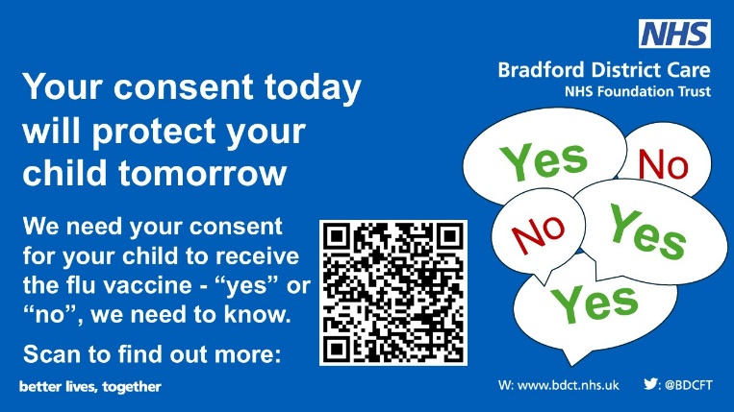
You can opt for your child to have the flu vaccine without porcine gelatine – an injection rather than the  nasal flu spray, but we must have your consent. Submit your online flu vaccine consent form by Thurs 30 Oct to enter a draw to win a £100 or £30 shopping voucher. Find out more: https://tinyurl.com/yp9r23cz | 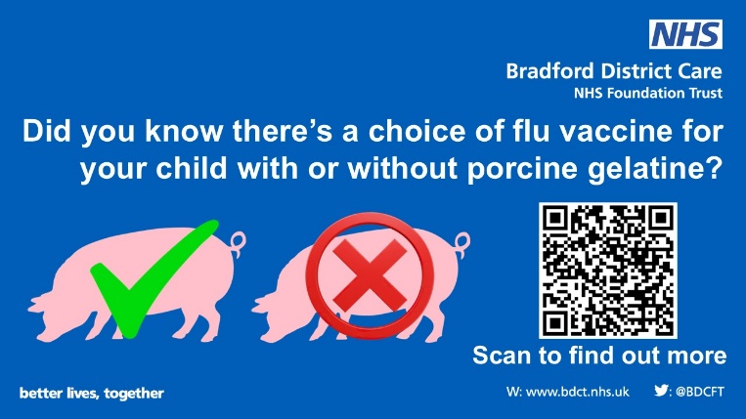
If your child has the flu vaccine, it helps to stop the spread of flu in your family and community. Flu viruses change, so even if they had it last year, they need it again this year. Submit your online flu vaccine consent form by Thurs 30 Oct to enter a draw to win a £100 or £30 shopping voucher. Find out more: https://tinyurl.com/yp9r23cz | 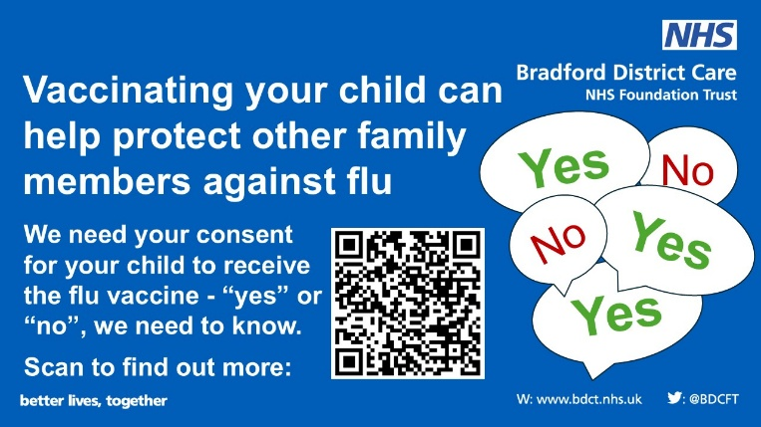
The flu vaccine is a quick and simple nose spray. It’s safe, effective, free and will stop the spread of flu, protecting not just your child but other family members. Submit your online flu vaccine consent form by Thurs 30 Oct to enter a draw to win a £100 or £30 shopping voucher. Find out more: https://tinyurl.com/yp9r23cz | 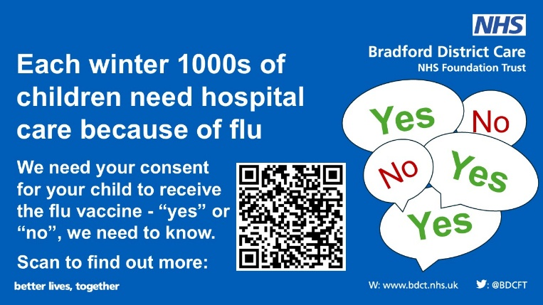
If you prefer your child to have an inactivate flu vaccine injection rather than the nasal spray which contains gelatine, that's fine. Let us know when you return the consent form - submit it by Thurs 30 Oct to enter a draw to win a £100 or £30 shopping voucher. Find out more: https://tinyurl.com/yp9r23cz | 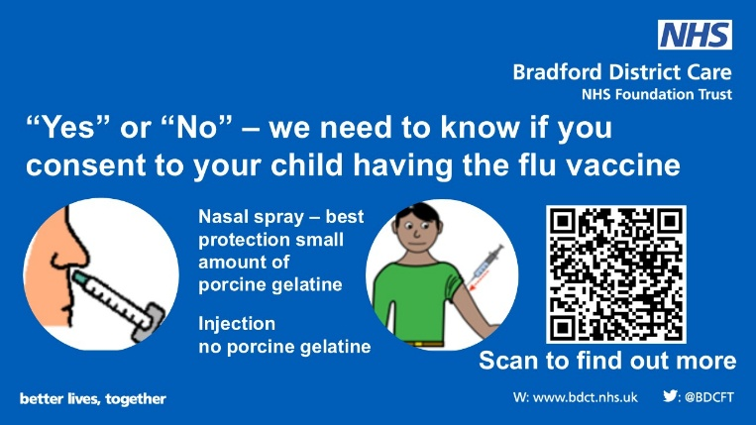
If you home-school your children, they can still have the flu vaccine at one of our community clinics. Submit your online flu vaccine consent form by Thurs 30 Oct to enter a draw to win a £100 or £30 shopping voucher. Find out more: https://tinyurl.com/yp9r23cz | 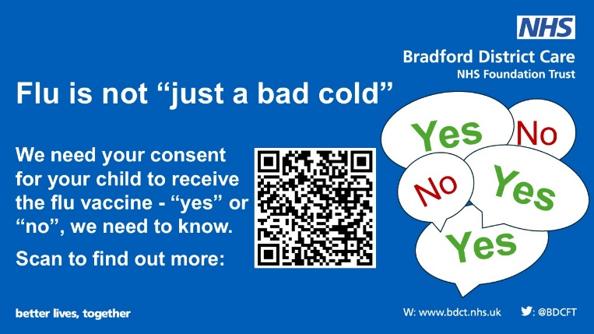
What is the flu vaccine? Is it safe? What do I need to do for my child to have the nasal spray at school? Get the answers to all your questions and submit your online flu vaccine consent form by Thurs 30 Oct to enter a draw to win a £100 or £30 shopping voucher. Find out more: https://tinyurl.com/yp9r23cz | 